Software Requirement Specification

TMSO-SRS-001

Version 1.0

**Revision History**

| Date | Version | Description | Author | Revised by |
| --- | --- | --- | --- | --- |
| 29/07/2013 | 1.0 | First version | Kha Nguyen | Khanh Nguyen |
| 09/08/2013 | 1.0 | Remove Close icon (“X” icon) on all pop-up, replace by Cancel button instead | Kha Nguyen | Khanh Nguyen |
| 13/08/2013 | 1.0 | Replace Advertise screen by Repair screen | Kha Nguyen | Khanh Nguyen |
|  |  |  |  |  |
|  |  |  |  |  |

Table of Contents

**1.** **Introduction** 5

**1.1** **Overview** 5

**1.2** **Scope** 5

**2.** **Functional Requirements** 6

**2.1** **Feature/Component #1: MyMobile Registration screen** 6

2.1.1 User Interfaces 6

2.1.2 Functional Requirements 6

**2.2** **Feature/Component #2: MyMobile Valuation Screen** 9

2.2.1 User Interfaces 9

2.2.2 Functional Requirements 9

**2.3** **Feature/Component #3: MyMobile Game Recommendation Screen** 11

2.3.1 User Interfaces 11

2.3.2 Functional Requirements 11

**2.4** **Feature/Component #4: MyMobile Podcast Recommendation Screen** 13

2.4.1 User Interfaces 13

2.4.2 Functional Requirements 13

**2.5** **Feature/Component #5: MyMobile Insurance Screen** 15

2.5.1 User Interfaces 15

2.5.2 Functional Requirements 15

**2.6** **Feature/Component #5: MyMobile Sell Screen** 17

2.6.1 User Interfaces 17

2.6.2 Functional Requirements 17

**2.7** **Feature/Component #6: MyMobile Donation Screen** 19

2.7.1 User Interfaces 19

2.7.2 Functional Requirements 19

**2.8** **Feature/Component #7: MyMobile Comparison Screen** 21

2.8.1 User Interfaces 21

2.8.2 Functional Requirements 21

**2.9** **Feature/Component #8: MyMobile Repair Screen.** 23

2.9.1 User Interfaces 23

2.9.2 Functional Requirements 23

**2.10** **Feature/Component #9: Mobile Inspection Screen** 26

2.10.1 User Interfaces 26

2.10.2 Functional Requirements 26

**2.11** **Feature/Component #9: MyMobile Trade Screen** 28

2.11.1 User Interfaces 28

2.11.2 Functional Requirements 28

**2.12** **Feature/Component #9: MyMobile Network Contract Screen** 30

2.12.1 User Interfaces 30

2.12.2 Functional Requirements 30

# **Introduction**

## **Overview**

This application allows identifies user’s phone and display’s it present value

## **Scope**

Demo version

Demo version is for display purpose only, not link to Database, not link to affiliated sites

Android OS: Android: OS 4.0.X to 4.1.X

* Android test devices: Galaxy Nexus, Nexus S, Samsung Galaxy S2

Android screen resolutions: 480x800, 720x1280

Support screen orientation in landscape mode only

# **Functional Requirements**

## **Feature/Component #1: Healines screen**

### User Interfaces

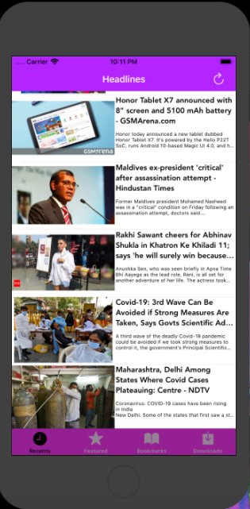

*Image1: Healines*

### Functional Requirements

|  |  |  |  |
| --- | --- | --- | --- |
| **Item** | **Description** | **Action** | **Response** |
| **Headlines screen** | Headlines screen has 5 buttons:   * Button refresh list news * View cell News * Button Fetured * Button Bookmark * Button Download   Screen has a Title Headlines | N/A | N/A |
| **Button refresh list news** | A button to refresh list news from api | Tap on the button | Refresh list news from api |
| **View cell News** | -Using to display news details  - Components included:   * Image news * Title news * News summary | Tap on the view cell | Display news details |
| **Button Fetured** | -Using to display category options  -Categories:   * Heath * Science * Entertainment * Technology | Tap on the button | Display category options |
| **Button Bookmark** | -Using to display the list of bookmarks that have been saved on the smartphone | Tap on the button | Display the list of bookmarks that have been saved on the smartphone |
| **Button Download** | -Using to display the list of downloads that have been saved on the smartphone | Tap on the button | Display the list of downloads that have been saved on the smartphone |

### 

## **Feature/Component #2: Featured screen**

### User Interfaces

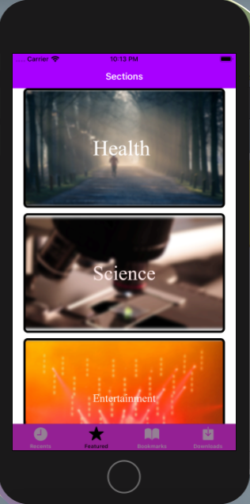

*Image 2: Featured screen*

### Functional Requirements

|  |  |  |  |
| --- | --- | --- | --- |
| **Item** | **Description** | **Action** | **Response** |
| **Featured screen** | Featured screen has 7 buttons:   * Heath button * Science button * Entertainment button * Technology button * Healines button * Bookmark button * Download button   Screen had title Sections | N/A | N/A |
| **Heath button** | - Using to display a list of health-related news  - Button details:   * Title Heath * Health related images | Tap on button | Display a list of health-related news |

|  |  |  |  |
| --- | --- | --- | --- |
| **Science button** | - Using to display a list of science-related news  - Button details:   * Title Science * Science related images | Tap on button | Display a list of science-related news |
| **Entertainment button** | - Using to display a list of entertainment-related news  - Button details:   * Title Science * Science related images | Tap on the button | Display a list of entertainment-related news |
| **Technology button** | - Using to display a list of Technology -related news  - Button details:   * Title Technology * Technology related images | Tap on the button | Display a list of Technology  -related news |
| **Healines button** | - Using to display a list of Healines-related news  - Button details:   * Title Healines * Healines related images | Tap on the button | Display a list of Healines  -related news |
| **Bookmark button** | -Using to display the list of bookmarks that have been saved on the smartphone | Tap on the button | Display the list of bookmarks that have been saved on the smartphone |
| **Download button** | -Using to display the list of downloads that have been saved on the smartphone | Tap on the button | Display the list of downloads that have been saved on the smartphone |

### 

## **Feature/Component #3: Detail News Screen**

### User Interfaces

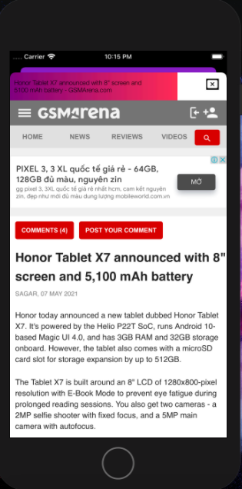

*Image3: Detail News*

### Functional Requirements

|  |  |  |  |
| --- | --- | --- | --- |
| **Item** | **Description** | **Action** | **Response** |
| **Detail News Screen** | Detail News Screen has 1 buttons and 1 detail news   * Exit button * Detail news | N/A | N/A |
| **Exit button** | Using to exit screen detail news then back to Headlines/Technology/Science/Entertainment/Heath screen | Tap on button | Return to previous screen |
| Detail News | Using to show detail news  . | N/A | N/A |

## 

## **Feature/Component #4: Bookmark Screen**

### User Interfaces

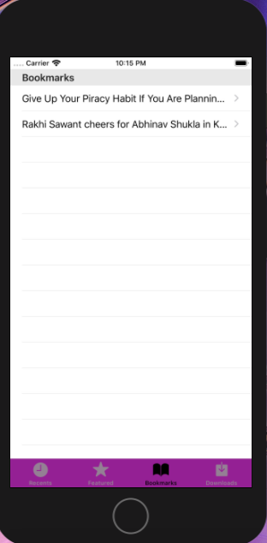

*Image 4: Bookmark screen*

### Functional Requirements

|  |  |  |  |
| --- | --- | --- | --- |
| **Item** | **Description** | **Action** | **Response** |
| **Bookmark Screen** | Bookmark Screen has 3 buttons and many bookmark view cell   * Headlines button * Featured button * Download button * Bookmark view cell | N/A | N/A |
| **Headlines button** | - Using to display a list of Healines-related news  - Button details:   * Title Healines * Healines related images | Tap on the button | Display a list of Healines  -related news |
| **Download button** | -Using to display the list of downloads that have been saved on the smartphone | Tap on the button | Display the list of downloads that have been saved on the smartphone |
| **Fetured Button** | -Using to display category options  -Categories:   * Heath * Science * Entertainment * Technology | Tap on the button | Display category options |
| Bookmark view cell | - using to display summon news | Tap on view cell | Display summon news |

### 

## **Feature/Component #5: MyMobile Insurance Screen**

### User Interfaces

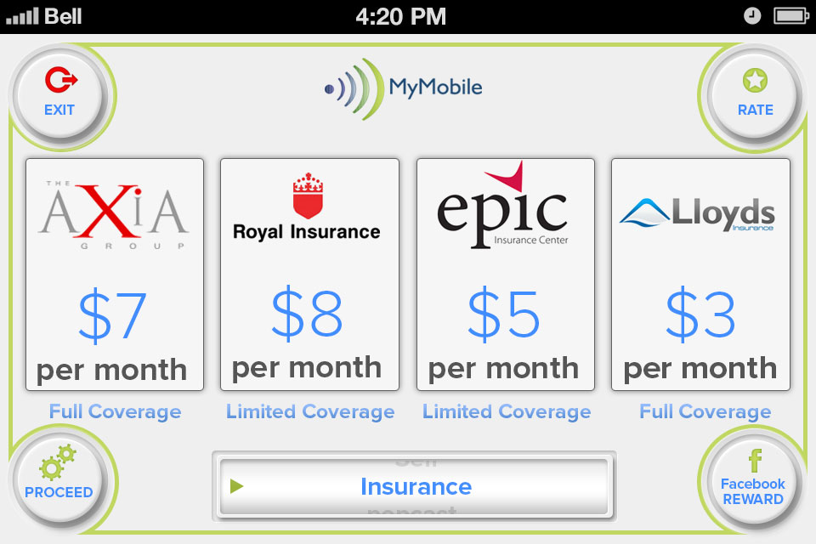

*Image5: Insurance*

### Functional Requirements

|  |  |  |  |
| --- | --- | --- | --- |
| **Item** | **Description** | **Action** | **Response** |
| **MyMobile Insurance Screen** | MyMobile Insurance Screen has 4 buttons and 1 navigation bar:   * Rate * Proceed * Facebook Reward * Exit * Navigation bar | N/A | N/A |
|  | Screen displays Four Quote's from Insurance companies with four icons | Tap on any icons | A pop up is appeared "This links to affiliated insurance partners website for fulfillment." |
| Rate | Shows Rate Pop Up - "In full version this will link to google play store or iTunes enabling users to rate the app." and Cancel Button at the top right hand corner | Tap on Rate button | A Rate pop up is showed |
| Cancel button to close pop up | Tap on the button | Pop up is closed |
| Proceed | Use with the navigation bar enables users to navigate to different screens | Tap on Proceed button | Navigate to the desired screen |
| Exit | Navigate to Valuation screen | Tap on Exit button | Navigate to Valuation screen |
| Navigation bar | Use to list items and pick the desired screen:   * Value * Compare * MyContract * Trade * Sell * Repair * Games * Podcast * Insurance * Donate * Inspect * www.mymobile.com.hk | Tap on Navigation bar and pick the desired screen | List items are displayed and the desired screen is picked |
| Facebook Reward | Use to post to Facebook & Receive Reward | Tap on Facebook Reward button | A Pop up " I just used MyMobiile App available from Google play, iTunes & www.mymobile.com.hk to insure my expensive smartphone for just 30 dollars per month and I received points towards a 10% discount electronics retail shopping voucher for telling my friends about it on Facebook." |

## **Feature/Component #5: MyMobile Sell Screen**

### User Interfaces

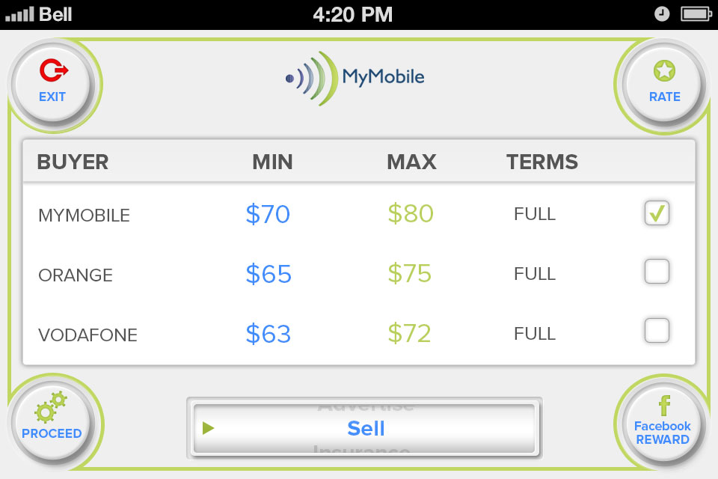

*Image6: Sell*

### Functional Requirements

|  |  |  |  |
| --- | --- | --- | --- |
| **Item** | **Description** | **Action** | **Response** |
| **MyMobile Sell Screen** | MyMobile Sell Screen has 4 buttons and 1 navigation bar:   * Rate * Proceed * Facebook Reward * Exit * Navigation bar | N/A | N/A |
|  | Screen displays the best buying prices for users mobile with Linked icons to affiliated partner websites. Each the buyer has a box and display the best buyer with name, Min and max of price, Term:   * Yodaphone $1500HKD $1800HKD Full * HKMobiles $ 1100HKD $1700HKD Full * Smart Recycle $800HKD $1200HKD PART | N/A | N/A |
| Rate | Shows Rate Pop Up - "In full version this will link to google play store or iTunes enabling users to rate the app." and Cancel Button at the top right hand corner | Tap on Rate button | A Rate pop up is showed |
| Cancel button to close pop up. | Tap on the button | Pop up is closed |
| Navigation bar | Use to list items and pick the desired screen:   * Value * Compare * MyContract * Trade * Sell * Repair * Games * Podcast * Insurance * Donate * Inspect * www.mymobile.com.hk | Tap on Navigation bar and pick the desired screen | List items is displayed and the desired screen is picked |
| Exit | Navigate to Valuation screen | Tap on Exit button | Navigate to Valuation screen |
| Facebook Reward | Use to post to Facebook & Receive Reward | Tap on Facebook Reward button | Pop up display " I just used MyMobiile App available from Google play, iTunes & www.mymobile.com.hk to Sell my old smartphone and I received points towards a 10% discount electronics retail shopping voucher for telling my friends about it on Facebook." |
| Check box | Each The best buyer has a check box to link the affiliated web of buyer | Tap on the check box | Check box is ticked |
| Proceed | When user has box ticked and presses proceed, Pop Up box appears with "User will be sent to affiliates website for fulfilment.” | Tap on Proceed button | Pop up is showed |

## **Feature/Component #6: MyMobile Donation Screen**

### User Interfaces

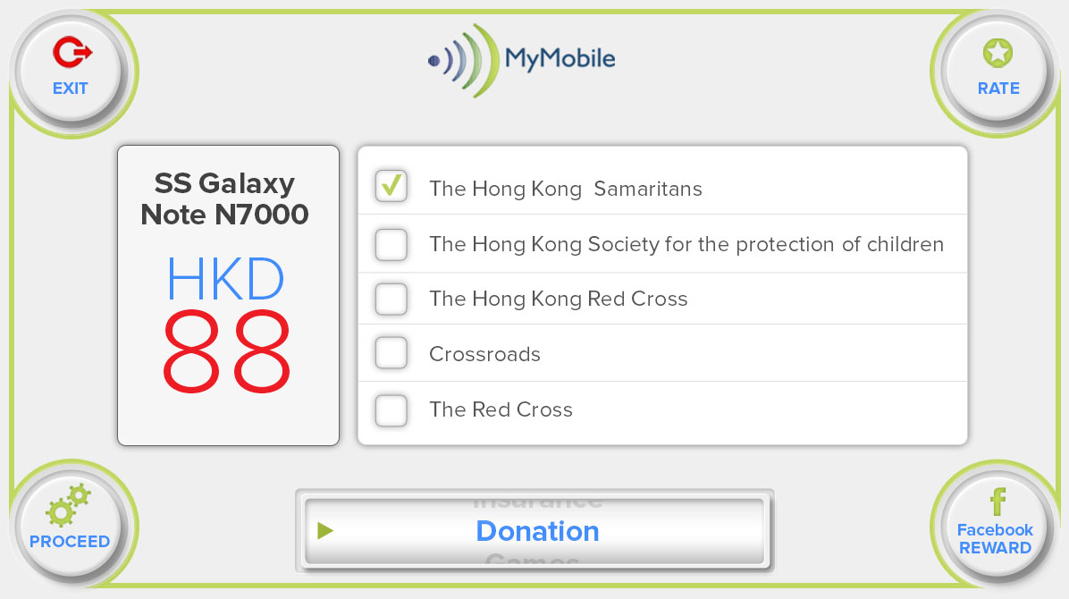

*Image7: Donation*

### Functional Requirements

|  |  |  |  |
| --- | --- | --- | --- |
| **Item** | **Description** | **Action** | **Response** |
| **MyMobile Donation Screen** | MyMobile Donation Screen has 4 buttons and a field to input Money with default currency is $.   * Rate * Proceed * Facebook Reward * Exit * Navigation bar | N/A | N/A |
| Screen displays info of phone   * The Phone is the Samsung Galaxy Note N700 * The Price is $1700HKD | N/A | N/A |
| Charity options will be:   * The Hong Kong Samaritans * The Hong Kong Society for the protection of children * The Hong Kong Red Cross * Crossroads * The Red Cross   Note: only a charity is ticked | Tap on the box | The desired charity is ticked |
| Rate | Shows Rate Pop Up - "In full version this will link to google play store or iTunes enabling users to rate the app." and Cancel Button at the top right hand corner | Tap on Rate button | A Rate pop up is showed |
| Cancel button to close pop up | Tap on the button | Pop up is closed |
| Navigation bar | Use to list items and pick the desired screen:   * Value * Compare * MyContract * Trade * Sell * Repair * Games * Podcast * Insurance * Donate * Inspect * www.mymobile.com.hk | Tap on the navigation bar and pick the desired screen | List items are displayed and the desired is picked |
| Exit | Navigate to Valuation screen | Tap on Exit button | Navigate to Valuation screen |
| Facebook Reward | Use to post to Facebook & Receive Reward | Tap on Facebook Reward button. | Pop up displays " I just used MyMobiile App available from Google play, iTunes & www.mymobile.com.hk to sell my smartphone and donate the proceeds to The hong Kong Society for the protection of children and I received points towards a 10% discount electronics retail shopping voucher for telling my friends about it on Facebook." |
| **Proceed** | Use to display A pop up appears "We will send a prepaid envelop to you from Recycle Limited wwww.recycle limited.com, once inspected all proceeds of the sale of your phone will go to your chosen charity and you will receive a receipt within 30 days. Please let people know of you kind gesture on Facebook. Thank You !" when user selects charity | Tap on Proceed button | A pop up is showed |

### 

## **Feature/Component #7: MyMobile Comparison Screen**

### User Interfaces

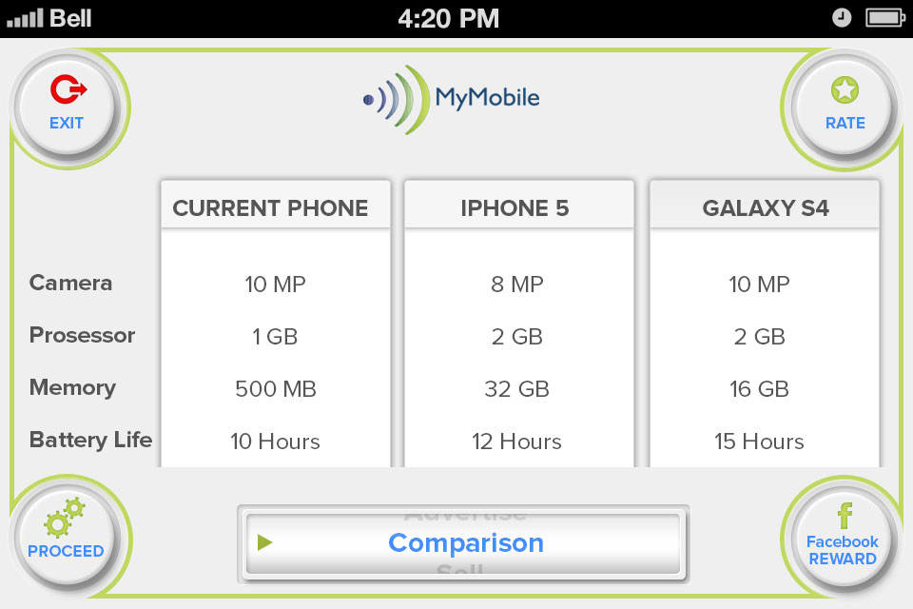

*Image8: Comparison*

### Functional Requirements

|  |  |  |  |
| --- | --- | --- | --- |
| **Item** | **Description** | **Action** | **Response** |
| **MyMobile Comparison Screen** | MyMobile Comparison Screen has 3 buttons and a field to input Money with default currency is $.   * Rate. * Exit. * Facebook Reward. * Proceed. * Navigation bar. | N/A | N/A |
|  | Screen Displays the info of the best 2 smartphones specs compared to the users current phone with the info:  Camera & Video  Screen size & Resolution  Processor & Data Speed  Weight  Ram & Memory | N/A | N/A |
| Rate | Shows Rate Pop Up - "In full version this will link to google play store or iTunes enabling users to rate the app." and Cancel Button at the top right hand corner | Tap on Rate button | A Rate pop up is showed |
| Cancel button to close pop up. | Tap on the button | Pop up is closed |
| Navigation bar | Use to list items and pick the desired screen:   * Value * Compare * MyContract * Trade * Sell * Repair * Games * Podcast * Insurance * Donate * Inspect * www.mymobile.com.hk | Tap on the navigation bar and pick the desired screen | List items are displayed and the desired is picked |
| Exit | Navigate to Valuation screen | Tap on Exit button | Navigate to Valuation screen |
| Facebook Reward | Use to Post to Facebook & Receive Reward. | Tap on Facebook Reward button. | Pop up displays button "I just used MyMobiile App available from Google play, iTunes & www.mymobile.com.hk to compare my smartphones specs to the latest models and I received points towards a 10% discount electronics retail shopping voucher for telling my friends about it on Facebook." |
| **Proceed** | Navigate to desired screen from navigation bar | Tap on Proceed button | Navigate to the desired screen |

## **Feature/Component #8: MyMobile Repair Screen.**

### User Interfaces

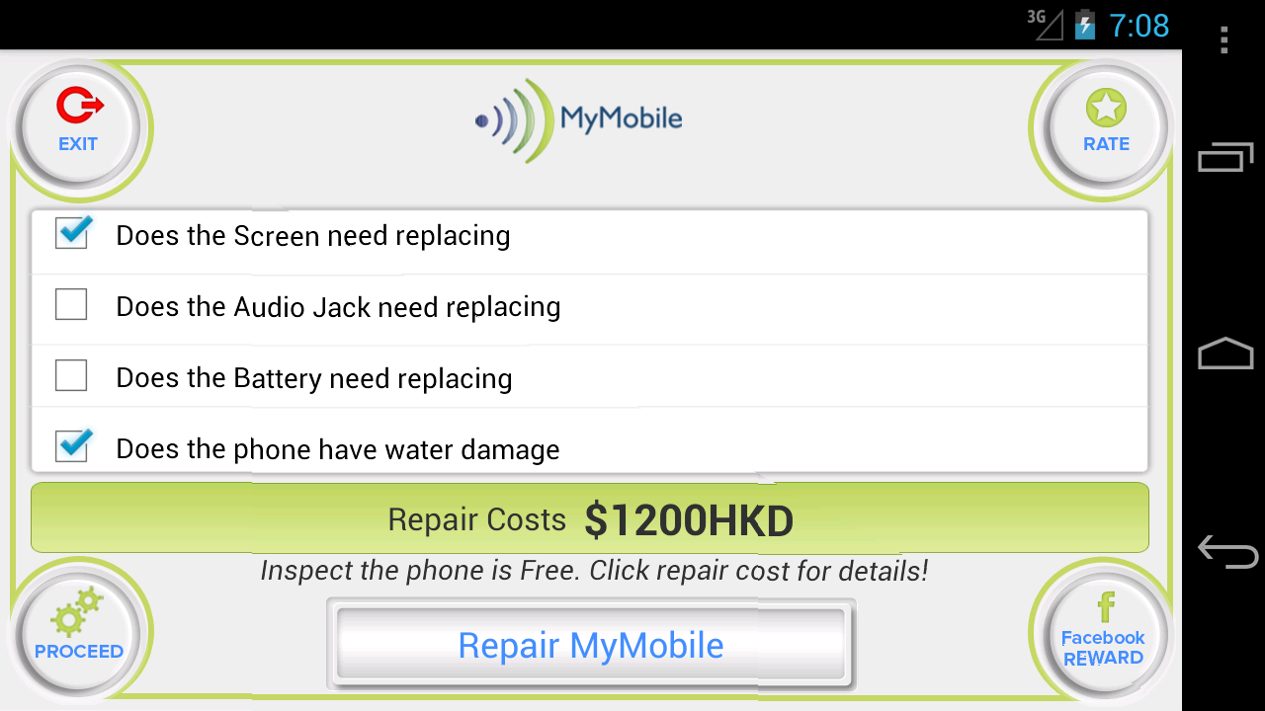

*Image9: Repair*

### Functional Requirements

|  |  |  |  |
| --- | --- | --- | --- |
| **Item** | **Description** | **Action** | **Response** |
| **MyMobile Repair Screen** | MyMobile Repair Screen displays a standard Repair for the users smartphone and has 4 buttons:   * Rate * Proceed * Facebook Reward * Navigation bar * Exit | N/A | N/A |
|  | Displays a selection of questions about What user wants to repair:   * Does the Screen need replacing * Does the Audio Jack need replacing * Does the Battery need replacing * Does the phone have water damage   Displays a text below Repair Costs: “Inspect the phone is Free Click repair cost for details” | N/A | N/A |
| **Display Value** | The string to display value.Based on What the user answers:   * Does the Screen need replacing - If checked Add $300 to the repair costs * Does the Audio Jack need replacing - if checked Add $250 to the repair costs * Does the Battery need replacing - if checked add $750 to the repair costs * Does the phone have water damage - If checked add $900 to the repair costs * if the user just checks Screen needs replacing the cost shows $300 * if the user checks Screen needs replacing and water damage the repair cost shows $1200 | N/A | N/A |
| **Box Next** | Each the question has a Check Box to pick | Tap on to boxt next answer questions | Box next is selected. Then expected value is displayed |
| **Repair Costs** | A Pop up shows, a dummy address as follows :  “We have e-mailed you a discount Reference code please show it to the repair centre & Please take your iPhone to  MyMobile Repairs  18 Harcourt Street  Wan Chai  Hong Kong  Ph. 2111 1111.” | Tap on Repair Cost Link | A pop up is showed |
| Rate | Shows Rate Pop Up - "In full version this will link to google play store or iTunes enabling users to rate the app." and Cancel Button at the top right hand corner | Tap on Rate button | A Rate pop up is showed |
| Cancel button to close pop up | Tap on the button | Pop up is closed |
| Navigation bar | Use to list items and pick the desired screen:   * Value * Compare * MyContract * Trade * Sell * Repair * Games * Podcast * Insurance * Donate * Inspect * www.mymobile.com.hk | Tap on the navigation bar and pick the desired screen | List items are displayed and the desired is picked |
| Facebook Reward | Use to post to Facebook & Receive Reward | Tap on Facebook Reward button | Pop up display " I just used MyMobiile App available from Google play, iTunes & [www.mymobile.com.hk](http://www.mymobile.com.hk/) to get a quote to repair it and I received points towards a 10% discount electronics retail shopping voucher for telling my friends about it on Facebook." |
| Exit | Navigate to Valuation screen | Tap on Exit button | Navigate to Valuation screen |
| Proceed | Use with the navigation bar enables users to navigate to different screens | Tap on Proceed button | Navigate to the desired screen |

## **Feature/Component #9: Mobile Inspection Screen**

### User Interfaces

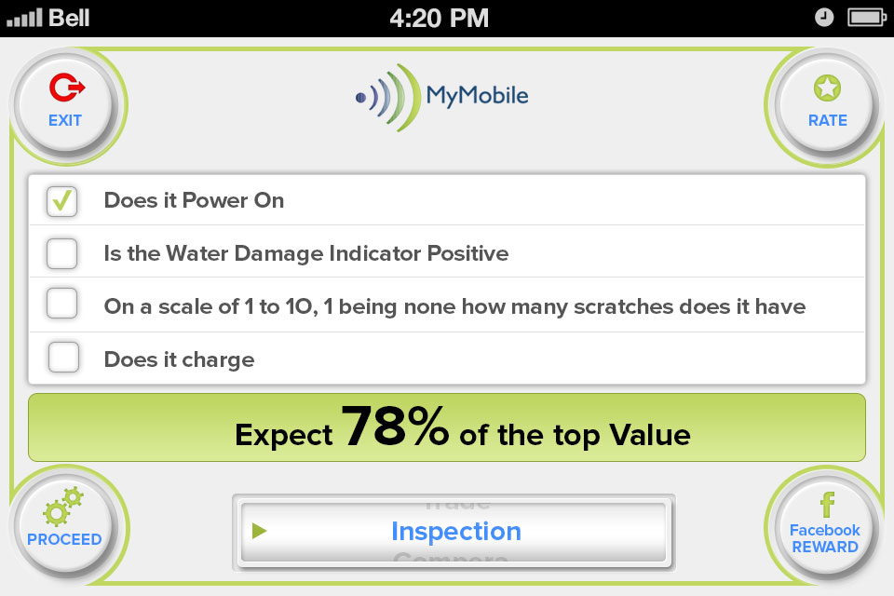

*Image10: Inspection*

### Functional Requirements

|  |  |  |  |
| --- | --- | --- | --- |
| **Item** | **Description** | **Action** | **Response** |
| **MyMobile Inspection Screen** | Inspection Screen displays has 4 buttons and 1 navigation bar:   * Rate * Navigation bar * Facebook Reward * Exit * Proceed | N/A | N/A |
|  | Displays a selection of questions about the state of the users phone.   * Does the phone power on * Is the Water Damage Indicator not Positive * Is the Screen not cracked * Does it charge | N/A | N/A |
| **Display value** | The string to display value.Based on weather the user answers:   * Does it power on Yes - if unchecked reduce 10% * Is the water damage indictor not positive - if unchecked reduce 40% * Is the screen cracked -if unchecked reduce 20% * Does it charge -if unchecked reduce 10% * if all 4 boxes are unchecked the customer can still expect to get 20% of the top value of the phone and If none of the boxes are unchecked get 100% | N/A | N/A |
| Rate | Shows Rate Pop Up - "In full version this will link to google play store or iTunes enabling users to rate the app." and Cancel Button at the top right hand corner | Tap on Rate button | A Rate pop up is showed |
| Cancel button to close pop up | Tap on the button | Pop up is closed |
| Navigation bar | Use to list items and pick the desired screen:   * Value * Compare * MyContract * Trade * Sell * Repair * Games * Podcast * Insurance * Donate * Inspect * www.mymobile.com.hk | Tap on the navigation bar and pick the desired screen | List items are displayed and the desired screen is picked |
| Exit | Navigate to Valuation screen | Tap on Exit button | Navigate to Valuation screen |
| Proceed | Use with the navigation bar enables users to navigate to different screens | Tap on Proceed button | Navigate to the desired screen |
| Facebook Reward | Use to post to Facebook & Receive Reward with a pop up is showed “I just used MyMobiile App available from Google play, iTunes & www.mymobile.com.hk to help me assess my smartphones condition / value and I received points towards a 10% discount electronics retail shopping voucher for telling my friends about it on Facebook." | Tap on Facebook Reward button | A pop up is showed |
| **Box Next** | Each the question has a Check Box to pick | Tap on to box next answer questions | Box next is selected. Then expected % value is displayed |

## **Feature/Component #9: MyMobile Trade Screen**

### User Interfaces

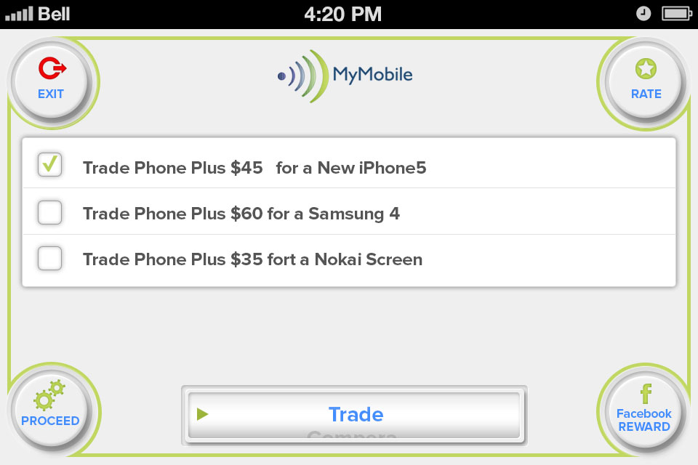

*Image11: Trade*

### Functional Requirements

|  |  |  |  |
| --- | --- | --- | --- |
| **Item** | **Description** | **Action** | **Response** |
| **MyMobile Trade Screen** | Trade Screen displays has 4 buttons and 1 navigation bar:   * Rate * Proceed * Facebook Reward * Navigation bar * Exit | N/A | N/A |
|  | Displays a selection of the best trade in  deals with our affiliated partners for that phone:   * Trade Phone Plus $2000HKD for a iPhone5S * Trade Phone Plus $1500HKD for a Samsung Galaxy Note II * Trade Phone Plus $1000HKD for a Google Nexus 4 * Trade Phone Plus $1000HKD for a Nokia Limia 920 * Trade Phone Plus $900 for a Motorola Droid RAZR | N/A | N/A |
| Rate | Shows Rate Pop Up - "In full version this will link to google play store or iTunes enabling users to rate the app." and Cancel Button at the top right hand corner | Tap on Rate button | A Rate pop up is showed |
| Cancel button to close pop up | Tap on the button | Pop up is closed |
| Exit | Navigate to Valuation screen | Tap on Exit button | Navigate to Valuation screen |
| Navigation bar | Use to list items and pick the desired screen:   * Value * Compare * MyContract * Trade * Sell * Repair * Games * Podcast * Insurance * Donate * Inspect * www.mymobile.com.hk | Tap on the navigation bar and pick the desired screen | Display list items and the desired screen is picked |
| Facebook Reward | Use to post to Facebook & Receive Reward | Tap on Facebook Reward button | Pop up display "I just used MyMobiile App available from Google play, iTunes & www.mymobile.com.hk to trade in my old smartphone for a new model and I received points towards a 10% discount electronics retail shopping voucher for telling my friends about it on Facebook." |
| **List of affiliated partner** | Each the partner has a check box and name  Note: Navigation * once the user moves the navigation bar any boxes which are checked, become unchecked | Tap on check box | The affiliated partner is ticked |
| **Proceed** | Pick proceed to Links to affiliated partner website which is ticked | Tap on Proceed button | A info pop up appears " this action will link directly to our affiliated partners website for fulfilment of order." |
| Ok button uses to link the affiliated partners website is : http://www.fortress.com.hk/en/home/ | Tap on Ok button | The affiliated partners website is linked |
| Cancel button on top right hand corner to close pop up | Tap on the button | Pop up is closed |

## **Feature/Component #9: MyMobile Network Contract Screen**

### User Interfaces

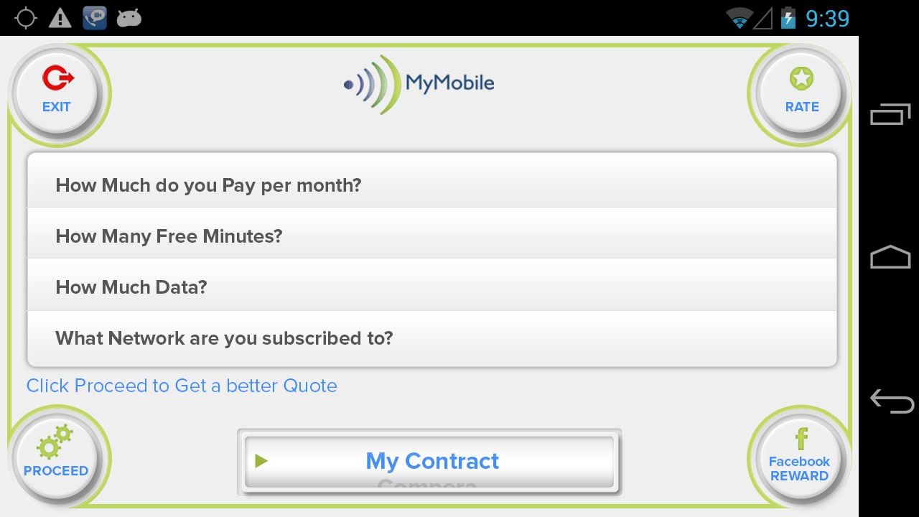

*Image12: MyContract*

### Functional Requirements

|  |  |  |  |
| --- | --- | --- | --- |
| **Item** | **Description** | **Action** | **Response** |
| **MyMobile Trade Screen** | Trade Screen displays has 4 buttons and 1 navigation bar:   * Rate * Proceed * Facebook Reward * Exit * Navigation bar | N/A | N/A |
|  | Displays a series of question buttons:   * What Network are you subscribed to? * How much Data? * How many free minutes? * How much you pay? | N/A | N/A |
| Rate | Shows Rate Pop Up - "In full version this will link to google play store or iTunes enabling users to rate the app." and Cancel Button at the top right hand corner | Tap on Rate button | A Rate pop up is showed |
| Cancel button to close pop up | Tap on the button | Pop up is closed |
| Navigation bar | Use to list items and pick the desired screen:   * Value * Compare * MyContract * Trade * Sell * Repair * Games * Podcast * Insurance * Donate * Inspect * www.mymobile.com.hk | Tap on the navigation bar and pick the desired screen | Display list items and the desired screen is picked |
| Exit | Navigate to Valuation screen | Tap on Exit button | Navigate to Valuation screen |
| Facebook Reward | Use to post to Facebook & Receive Reward. | Tap on Facebook Reward button | Pop up display "I just used MyMobiile App available from Google play, iTunes & [www.mymobile.com.hk](http://www.mymobile.com.hk/) to get a better cheaper mobile contract quote and I received points towards a 10% discount electronics retail shopping voucher for telling my friends about it on Facebook.” |
| **Question list** | What Network are you subscribed to?  Has 5 options to answer, each options have a check box before it   * China Mobile * 3 * CSL * PCCW * Smartone | Tap on the check box | Desired Network provider is ticked |
| How much Data?  Has 9 options to answer, each options have a check box before it   * Zero * Unlimited * 200 * 400 * 600 * 800 * 1gb * 1.5gb * 2 and above | Tap on the check box | Desired Data is ticked |
| How many free minutes?  Has a text field to enter. | Tap on the text field. | The info is entered. |
| How much you pay?  Has a text field to enter. | Tap on the text field. | The info is entered. |
| **Proceed** | Display a pop up with "We will make sure you are on the best deal, if not we will send you out better deals on offer from your current and competitor networks." | Tap on Proceed button. | Pop up is showed. |

***---------- End of Document ----------***